**Standard Operating Procedure (SOP) for Running Streamlit Career Exploration App and Generating PDF Reports**

**Objective:**

This SOP provides detailed instructions for two processes:

1. Running a Streamlit web application for career exploration and college details.
2. Generating PDF reports containing college and job details using the Python script.

**Prerequisites:**

**For Running Streamlit App:**

* Python installed on your system (version 3.6 or higher).
* Required Python libraries installed: pandas, streamlit, boto3, PIL (Pillow), and others as specified in the script.
* AWS S3 account with appropriate credentials.
* Access to the internet to load external images and websites.

**For Generating PDF Reports:**

* Python environment with required libraries installed (FPDF, HTMLMixin, io, tempfile, BytesIO, Image from PIL, boto3, pandas, Streamlit).
* AWS S3 access credentials (AWS ID and AWS Secret Access Key).
* AWS S3 bucket containing Excel files with college and job details.

**Part 1: Running the Streamlit Career Exploration App**

**Step 1: Importing Libraries**

1. Open a Python environment or code editor.
2. Import the necessary libraries using the provided script. 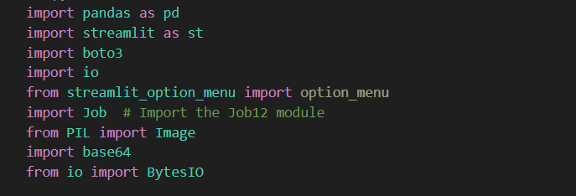

**Step 2: Loading Data from AWS S3**

1. Replace **aws_id**, **aws_secret**, **bucket_name**, **object_key_clg**, and **object_logo** with your AWS credentials and S3 bucket information.
2. Load data from AWS S3 using the provided code. 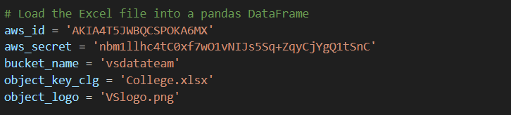

**Step 3: Converting Image to Base64 String**

* 1. Use the provided function to convert the logo image to a base64-encoded string. 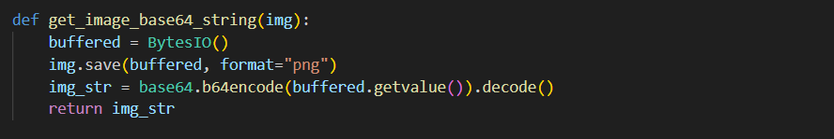

**Step 4: Creating the Streamlit Interface**

1. Define the Streamlit interface within the **main()** function. This includes the title, user inputs, and college details display.
2. Implement user inputs and error handling as specified in the script.

**Step 5: Handling the Next Page**

1. Check if the next page should be displayed and, if so, display the "Job12.py" page using the **Job.main()** function.

**Step 6: Running the Application**

1. To run the application, execute the script in your Python environment using the following command: 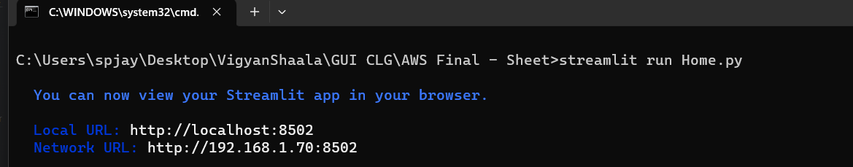
2. Open a web browser and go to the URL provided by Streamlit (usually [http://localhost:8501](http://localhost:8501/)) to access the application.
3. Enter your name and select your desired degree, field, subfield, and college. 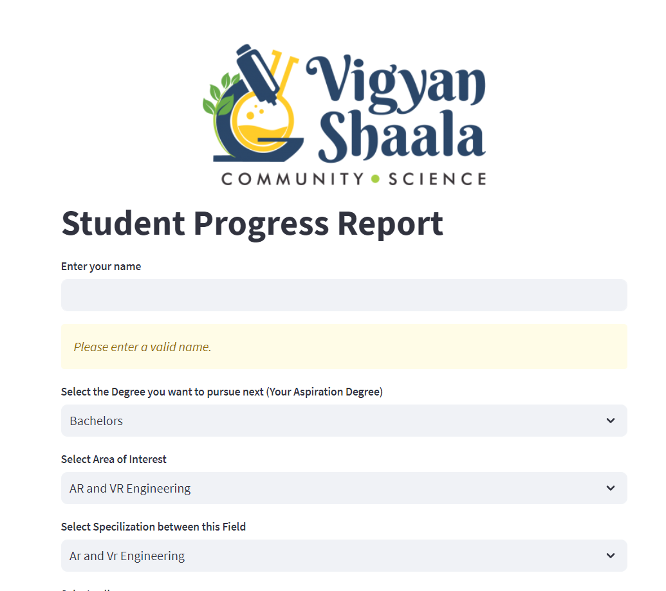
4. Click the "Explore Career" button to proceed to the next page. 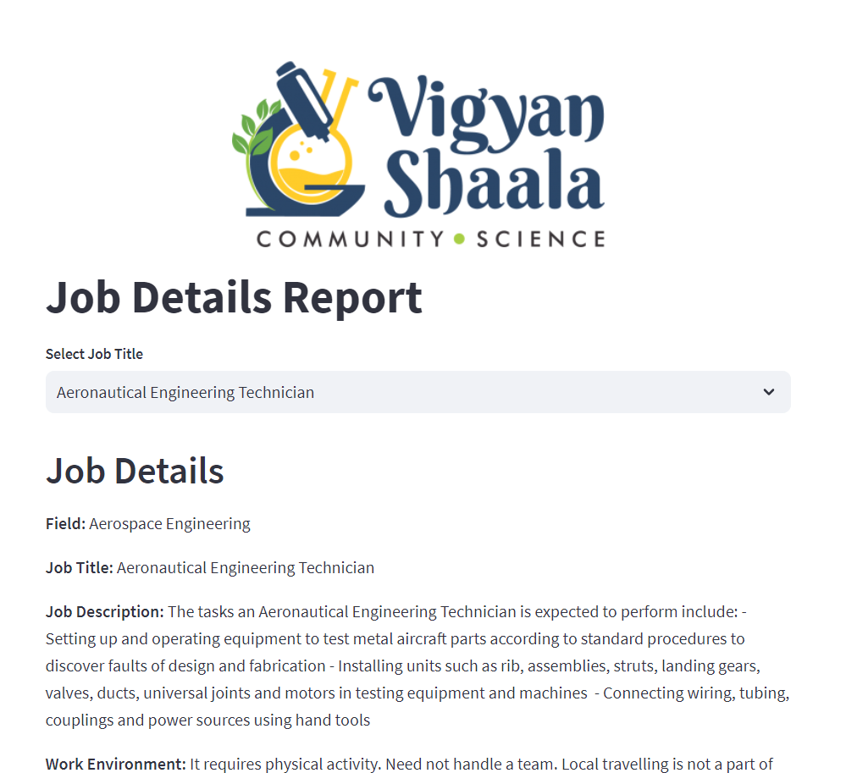

**Part 2: Generating PDF Reports from College and Job Details**

**Step 7: Setup Environment**

1. Open your command-line interface or terminal.
2. Navigate to the directory containing the Python script.
3. Ensure you have Python installed and set up a virtual environment if needed.
4. Install the required Python libraries using **pip**: 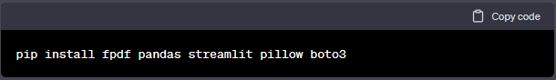

**Step 8: AWS S3 Configuration**

1. Obtain your AWS S3 access credentials (AWS ID and AWS Secret Access Key). 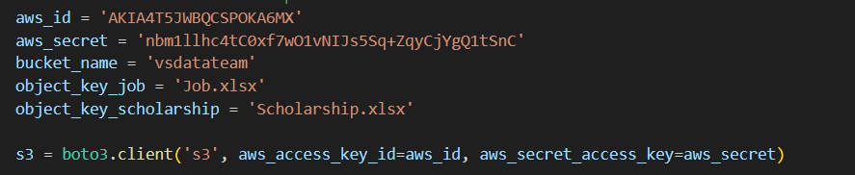
2. Ensure you have access to the S3 bucket containing the Excel files with college and job details.

**Step 11: Select College and Job Details**

1. After selecting college and job details in the Streamlit application, scroll down to view the generated content.

**Step 12: Generate the PDF Report**

1. Click the "Download PDF" button to download the PDF report containing the selected college and job details.

**Step 13: Repeat as Needed**

1. You can repeat the process as many times as needed to generate PDF reports with different college and job details.

**Step 14: Close the Streamlit Application**

1. Once you have generated the desired PDF reports, close the Streamlit application by stopping it in the terminal (usually by pressing **Ctrl+C**).

**Conclusion:**

This comprehensive SOP provides step-by-step instructions for running the Streamlit career exploration web application and generating PDF reports. Ensure that you have the necessary environment set up and AWS S3 credentials configured before executing the script.